**VERTEBRAL COLUMN**

**Definition:** It is the skeleton of the trunk of the body.

**Shape of vertebral column:** It is S-shaped when viewed from the side.

**Bones of vertebral column**

The vertebral column is composed of a series of bones called vertebral. In the average adult the vertebral column measures about 71cm (28inches in length).

The vertebral column is a strong and flexible structure that moves;

* Anteriorly (flexion)
* Posteriorly (extension) and
* Laterally (lateral flexion)

The adult vertebral column contains 33 vertebrae. These are distributed as follows;

* Cervical – 7
* Thoracic – 12
* Lumbar – 5
* Sacral – 5
* Coccyac – 4

**Functions of vertebral column**

* It encloses the spinal cord
* It protects the spinal cord
* It supports the head (skull)
* It provides access to spinal nerves and blood vessels through intervertebral foramina.
* It enables certain movements e.g. flexion, extension and lateral flexion.
* Intervertebral discs acts as a shock absorber thus protecting the brain.
* It forms the axis of the trunk.
* Maintain posture in upright standing.
* It serves as a point of attachment for ribs, shoulder girdle, pelvic girdle and muscles of the back.

**Normal curves of vertebral column**

When the vertebral column is viewed from the side, it shows four natural curves. These includes;

* Cervical
* Thoracic
* Lumbar and
* Sacral

**Importance of spinal curves**

* They increase strength of vertebral column.
* They help maintain balance in upright position.
* They absorb and distribute shock during walking, running and jumping.
* They allow an even distribution of body weight.
* They allow flexibility during column movement.
* They help protect vertebral column from fractures.

**Diagram of normal curves of vertebral column**

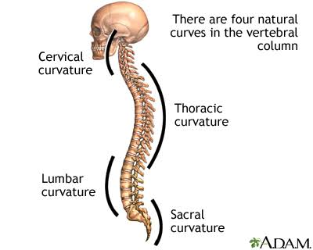

**Abnormal curves of vertebral column**

**Definition:** These are deviations from the normal spinal curves.

They include the following;

**Scoliosis:** The spine rotates and develops a side-to-side curve.

**Kyphosis:** An exaggerated forward bending (rounding) of the upper back.

**Lordosis:** It is an extreme forward curvature (deep curve) of the lower back.

**Diagrams of abnormal curves of vertebral column**

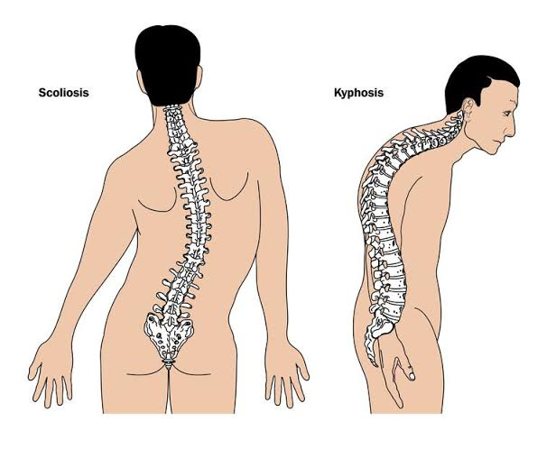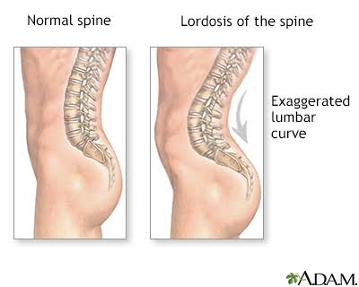

**Parts of a typical vertebral bone**

The typical vertebral is made up of an anterior and posterior part as shown in the diagram below.

A typical vertebral bone consists of the following parts.

* **Vertebral arch:** This part encloses the vertebral foramen posteriorly.
* **Vertebral foramen:** This is the opening for the passage of spinal cord.

NB: When all the vertebrae are jointed together with each vertebral foramina lying one above the other, a vertebral canal is formed. The spinal cord lies in this canal.

* Spinous process: This projects backward from the vertebral arch.
* Transverse process: This project laterally from each side of the vertebral arch.
* Body: That part of vertebral bone which lies anteriorly to the vertebral foramen. The vertebral body varies in size and shape depending on the level of the spine it belongs to.
* The pedicle: Is that part of the vertebral arch which lies between the vertebral body and transverse process.
* The lamina: Is that part of the vertebral arch lying between the transverse process and the spinous process.
* Intervertebral foramen: There are opening found between vertebral bones which allows passage of nerves and blood vessels.

**Diagram of a typical vertebral bone.**

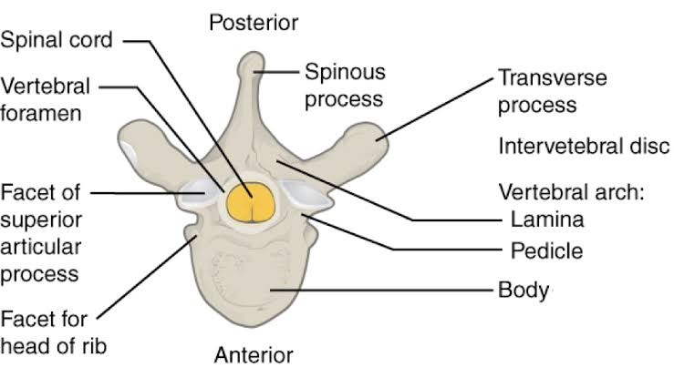

**Comparison of Cervical, Thoracic, Lumbar, Sacral and Coccygeal Vertebrae**

**Coccygeal vertebrae**

**Cervical vertebrae (7) in number**

**The atlas:** This is the first cervical vertebra. It is called so because it holds the globe of the head.

**The axis:** This is the second cervical vertebra. It is named so because it forms an axis around which the atlas and the head can rotate.

The 7th cervical vertebra: This vertebra has a long spinous process which is prominent on palpation.

**Characteristics**

* They have transverse foramina located on transverse process.
* Their bodies are smaller than the other vertebrae.
* Have large vertebral foramina.
* Spinal cord size is large in this level.

**Thoracic vertebrae (12) in number**

**Characteristics**

* They have bodies of intermediate size.
* Have long, slender spines
* They have costal facets on the sides of bodies for articulation with head of ribs.
* They have facets on transverse process of upper nine or ten thoracic vertebrae to articulate with tubercles of ribs.
* Vertebral foremina are smaller.
* Spinal cord size is smaller at this level.

**Lumbar vertebrae (5) in number**

**Characteristics**

* They have no costal facets.
* They have no transverse foramina.
* Their bodies are large and thick.
* Have fairly long transverse process.
* Have flat, rectangular shaped spine.
* Have facets on their superior and injerior surfaces for articulation with vertebrae above and below respectively.

NB: The lumbar spine is the largest segment of the mobile parts of the vertebral column.

**The Sacrum (5) in number**

**Characteristics**

* Formed by the fusion of five sacral bones
* The sacrum is triangular in shape.
* Each vertebra is slightly smaller then the one above it (thus forming a triangular shape)
* There are four pairs of sacral foramina.

**The Coccyx (4) in number**

**Characteristics**

* Formed by the fusion of four coccygeal vertebrae
* The coccyx is triangular in shape.
* Each vertebra is smaller than the one above it (thus forming a triangular shape).

**Intervertebral discs**

**Definition:** These are fibro cartilaginous structures formed between vertebral bones.

**Parts of intervertebral discs**

**The annulus fibrosus**

It is made of circular layers of fibrous and fibro cartilaginous tissue.

It forms the outer layer of the disc and surrounds the nucleus pulposus.

**Function**

* It holds that vertebrae together and contribute to its stability.
* It houses the nucleus pulposus.
* It also acts as a shock absorber to forces transmitted along the vertebral column.

**THE NUCLEUS PULPOSUS**

This is made of a semi-liquid gelatinous substance. The semi liquid material allows it to change its shape easily to permit various movements of the vertebral column.

It forms the inner layer of the disc and lies within the ring of annulus pulposus.

**Function**

* It permits various movements of vertebral column (flexibility).

NB: The intervertebral discs account for about ¼ of the height of the vertebral column.

**General functions of intervertebral discs (Both annulus & Nucleus pulposus combined)**

* Absorb shock transmitted along the column.
* Prevents the vertebrae from grinding against each other.
* Holds vertebral bones together.
* Allows flexibility of the column.

**Diagram of intervertebral disc**

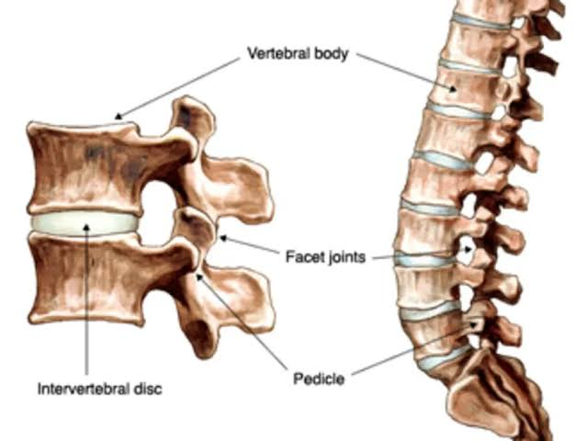 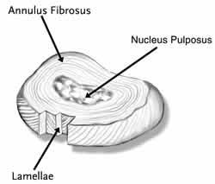

**Joints of vertebral column**

1. **Atlanto – axial joint**: Joint between atlas and axis.
2. **Lumbo-sacral joint:** Joint between the 5th lumbar vertebra and the 1st sacral vertebra.
3. **Sacro-coccygeal joint:** Joint between 5th sacral vertebra and 1st coccygeal vertebra.
4. **Atlanto-occipital joint:** Joint between the atlas and the occipital bone of skull.

**Stabilizers of vertebral column**

1. **Ligaments**

* Anterior longitudinal ligament- joints the anterior surfaces of vertebral bodies together.
* It runs from occipital bones to front of sacrum.
* Posterior longitudinal ligament- lies inside the vertebral canal. It runs from the axis to the sacrum.
* Ligament flava (yellow ligament) – joints lamina of one vertebra with that of the adjacent vertebra.

NB: The above are the three largest ligaments which stabilize vertebral column.

**Others include:**

* Supraspinous ligament: Connect spinous process. Runs from 7th cervical vertebra to the sacrum.
* Ligamentum nuchae- runs from occipital to the spine of the 7th cervical vertebra. It attaches all spinous process in the cervical area.
* Interspinous ligaments: Connects adjacent spines.
* Intertransverse ligaments: Connect the transverse processes.

1. The strong muscles of back.
2. Intervertebral discs- they hold the vertebrae together.

**Movements of vertebral column**

* Flexion
* Extension
* Lateral flexion and
* Rotation

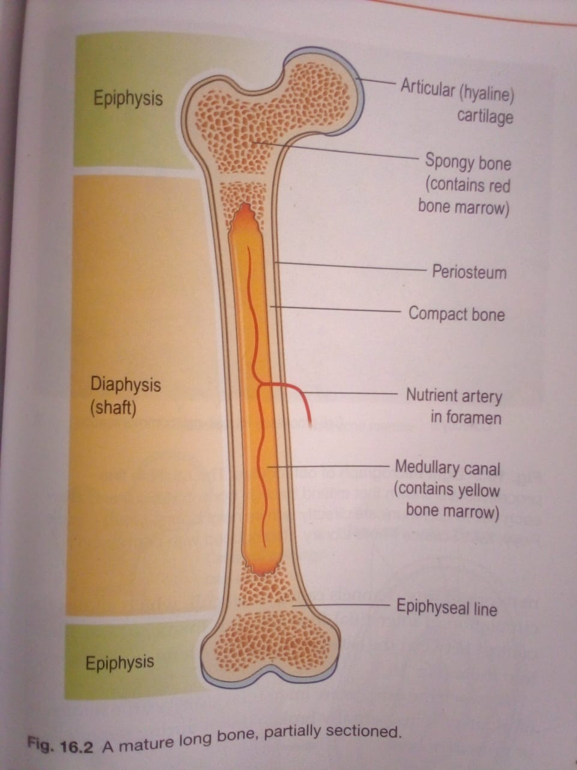 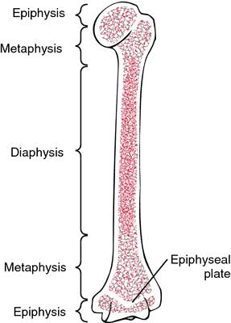

*Mature long bone* *Bone epiphysis, Metaphysis and diaphysis*

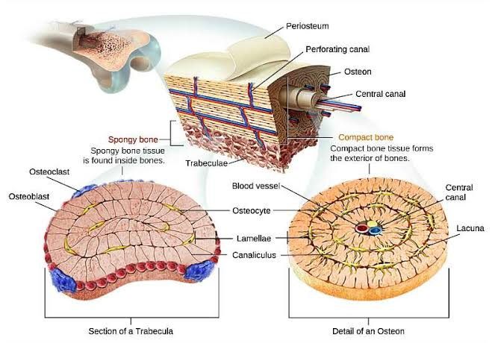`

***Cross section of abone***